Work Instruction Version 1.0

Amadeus Marine Ltd. – Drawing Database

hERMA GROUP OF COMPANIES

INFORMATION AND COMMUNICATION TECHNOLOGY DEPARTMENT

2021

# Table of Contents

Revision History 2

1. Responsibilities and Accountabilities 3

2. Interface Elements and Descriptions 4

3. Accessing Drawing Access Database 6

4. Logging into Drawing Access Database 6

5. Navigating Inside Drawing Access Database 7

6. Available Actions and its Step by Step Procedure For Live and Local DAD 8

1. View Ship Building Hull Records 8

2. View Ship Repair Hull Records 9

3. Search Hull 9

4. Add New Hull 9

5. Update Hull Details 10

6. Delete Hull 12

7. View Special Project Drawing Records 13

8. View Ship Building and Ship Repair Drawing Records 13

9. Search Drawing 14

10. Add New Drawing 15

11. Update Drawing Details 15

12. Upload Drawing Revision 16

13. View Drawing Revision History 17

14. Download Drawing 18

15. Delete Drawing 18

16. View Draft Records 19

17. Search Draft 20

18. Add New Draft 20

19. Update Draft Details 21

20. Finalize Draft Record 23

21. Delete Draft 24

# Revision History

|  |  |  |
| --- | --- | --- |
| ****Date**** | ****Module**** | ****Change Description**** |
|  |  |  |
|  |  |  |
|  |  |  |
|  |  |  |
|  |  |  |

# Responsibilities and Accountabilities

1. adMINISTRATOR - an appointed officer that will oversee the following processes:
   1. Enroll new user.
   2. Assign role for new and existing users.
2. MODERATOR – an apponit
3. uploader - an appointed officer that will oversee the following processes:
   1. Manage Hull Records.
      1. Create new Hull record.
      2. Update Hull details.
      3. Delete hull record.
   2. Manage Drawing Records.
      1. Create new Drawing record.
      2. Update Drawing details.
      3. Upload Drawing Revisions.
      4. Delete Drawing Record.
   3. Manage Preliminary Drawing Records.
      1. Create new Draft Record.
      2. Update Draft Details.
      3. Finalize Draft Record.
      4. Delete Draft Record.
4. User – any officer that will be authorized to view and to download drawing files.

# Interface Elements and Descriptions

This section lists down interface terms for the system with their corresponding behavior. The list of interface terms is presented in following table:

|  |  |  |  |  |
| --- | --- | --- | --- | --- |
| Interface Term | Behavior and Description | | | |
| Browser | * An application or program that enables a user to look and interact with information on the internet * Example of recommended browsers:  |  |  |  |  | | --- | --- | --- | --- | |  |  |  |  | | Chrome  Version 63 | Firefox  Version 58.0.2 | Internet Explorer  Version 11.248 | Safari  Version 11 | | | | |
| Web app | * Is a system application that accessed through a browser. | | | |
| Click | * Is a method of selecting an item on the interface by pressing the left button once and releasing it; or, by pressing at the item on the screen using a pointer (e.g. for touchscreen, tablet, smartphone, etc.) | | | |
| Button | * Can be selected using a pointer. | | | |
| Link | | * A clickable text or words that is a reference to a data or web page on the internet. * Usually, the cursor changes whenever it is hovered on a link. | | |
| Field | | * Are items in the interface/page where users can enter data. | | |
| Textbox | | * A field that accepts text or number. | | |
| Dropdown | | * A field with a downward arrow button that enables the user to select a value from a list. | | |
| Form | | * A group of fields that are closely related to each other and serves a model or group of data. | | |
| Table | | | | * Are groups of data or information that is organized like a table. |
| File | | | * It is a collection of data that is stored in one unit that is identified by a filename. It can be a document, picture, application, audio/video, etc. * Example of files:   + Native file format for AutoCad (.dwg)   + Portable Document Format (.pdf)   + Design Web Format (.dwf) | |

# Accessing Amadeus Drawing Database

1. Recommended to use “Chrome” to access the web app, but other browsers mentioned in the table above may also be used.
2. On the address bar of the browser window, type <http://dad.hermashipyard.com/> as shown on Figure then hit Enter on your keyboard.

|  |
| --- |
| **Note:** If the Page returns a 404 message or “Page not found”, the web application may be temporarily down for maintenance. The user may contact an ICT officer or look for an email notice regarding the issue. |

# Logging into Amadeus Drawing Database

This form will allow the user to be authenticated within the web application. The interface and the behavior of the application will vary depending on the role of the user that is logged in. The Administrator will assign usernames and passwords to every allowed user for monitoring.

1. **Email Address –** Users are to input here the email address that is assigned or provided to them by the administrator.

|  |
| --- |
| **Note:**  Administrator assigned user’s O365 email account. |

1. **Password** – Users are to input here their registered password that is associated with their user accounts.

|  |
| --- |
| **Note:** Password field characters is hidden and case-sensitive |

1. **Remember Me** – This will allow browser to remember the registered user’s credential and will not go through the login page again when a new tab or session is opened.
2. **Login** – This button is to be clicked once the user had accomplished all the above fields. All successful login will be directed to an applicable landing page per role.
3. Any invalid attempt to log in, a message will be shown just above the username field:

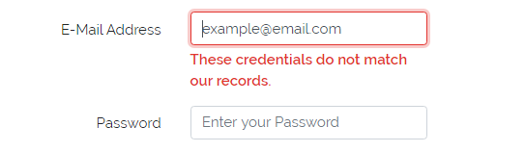

# Navigating Inside Amadeus Drawing Database

This section aims to instruct the user on how to navigate through the system by defining the main sections of the interface. For this section, the common landing page is displayed.

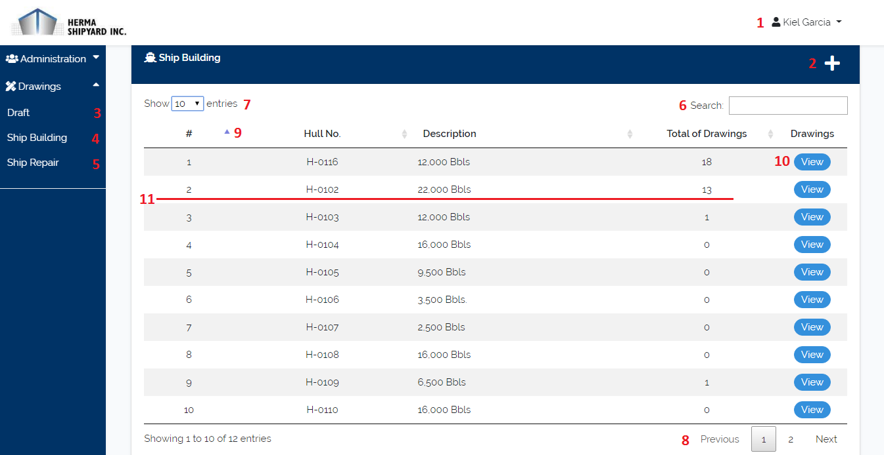

Image 1. Drawing Access Database – Hull Record Interface

Image 2. Drawing Access Database – Drawing Record Interface

1. User – Displays the name of the current user and options “Need Support?” to request support from IT and “Logout” of the system.
2. New Hull Button - Button that creates new hull.
3. Draft Menu – This section is for storing and viewing preliminary drawings or for approval drawings.
4. Ship Building Menu – This section is for maintaining ship building hull records.
5. Ship Repair Menu – This section is for maintaining ship repair hull records.
6. Search Bar – A text box that allows the user to search through the records. The user can input the information they want to search. System will automatically filter the records based on users input.
7. Table Size – Determines if how many records will be shown per page of the table.
8. Table Pagination – Contains the other records of table.
9. Sort Icon – Allows sorting of records according to the corresponding data type.
10. View Button – Button that open the drawing records of a specific hull.
11. Hull Record – a table row is clickable for viewing details and updating details.
12. New Drawing Button – A button that creates new drawing.
13. Download Buttons – Set of buttons that user allows to download file as PDF, DWF and DWG.
14. Drawing Record – a table row is clickable for viewing details and updating details.

# Available Actions and its Steps-by-steps Procedure

## Enroll New User

1. On the side navigation bar, click **Users Management** menu.
2. On the **Users** tab, click **New User** button.
3. Fill-out the required fields, name, email, & Role. Then click **Save** button.
4. After adding new user, temporary password will be sent into enrolled email.

## View Ship Repair Hull Records

1. On the side navigation bar, click “Drawings” and select “Ship Repair” from the dropdown menu.

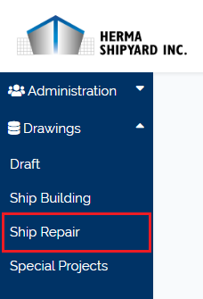

1. It will be linked on “Ship Repair” page.

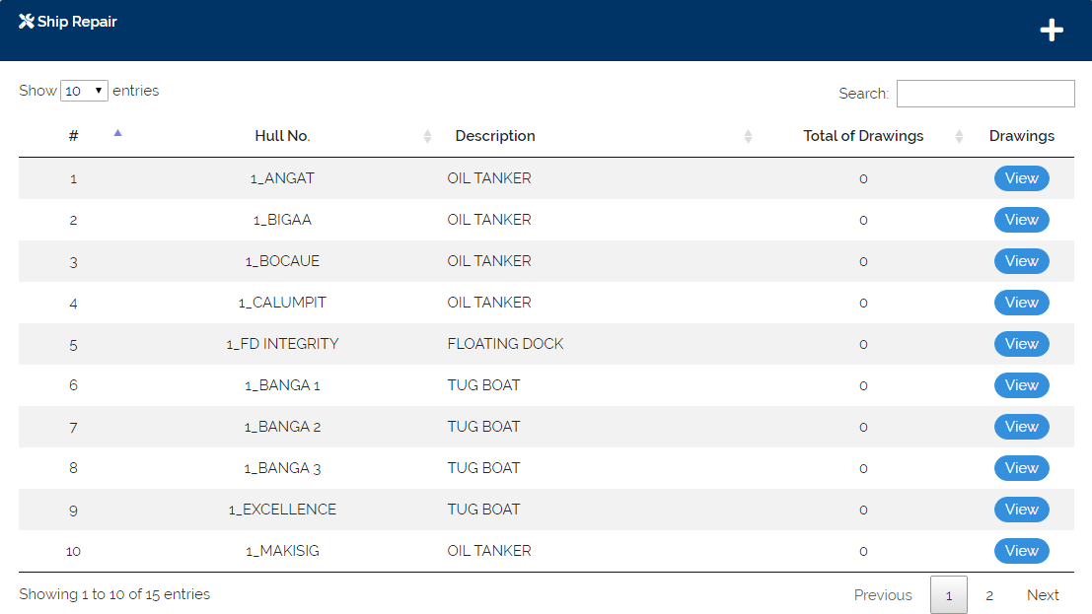

## Search Hull

1. Click on the search text box and input a hull details. System will automatically filter the records based on users input.

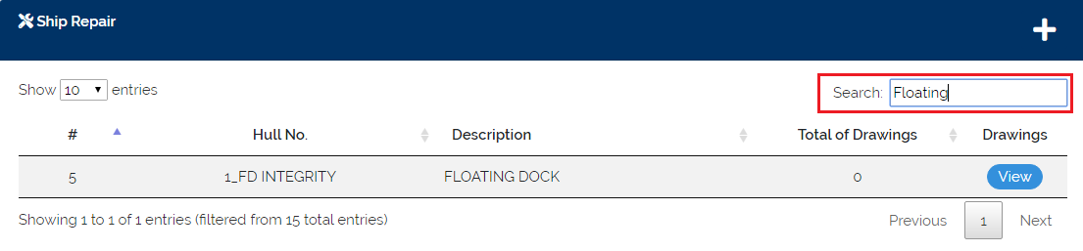

## Add New Hull

1. Click “**+**” button in the “Ship Building/Ship Repair” page.

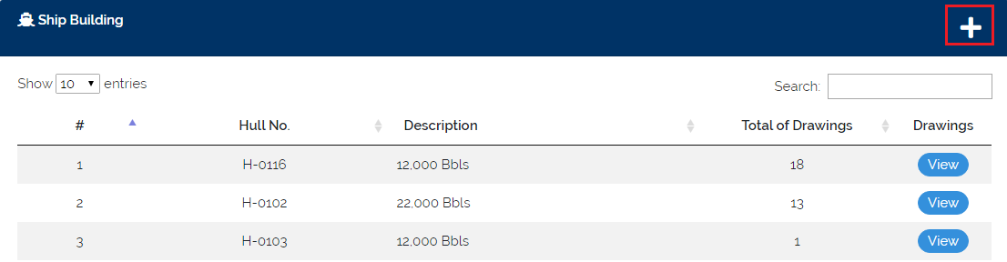

1. Fill up the required fields in new hull form. Click “Save” button when you are done.

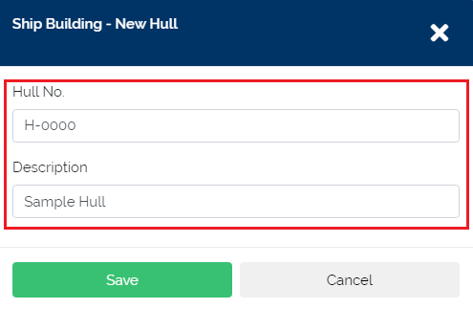

## Update Hull Details

1. Click a specific hull record, in the “Ship Building/Ship Repair” table.

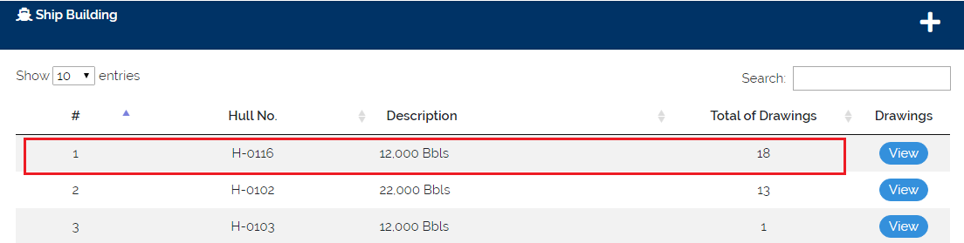

1. Hull details will be shown. Click the “Update” button to disable text fields.

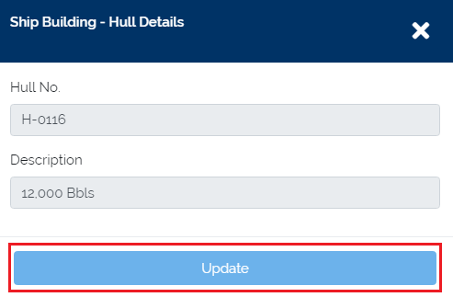

1. Click “Save Changes” button, when changes are done.

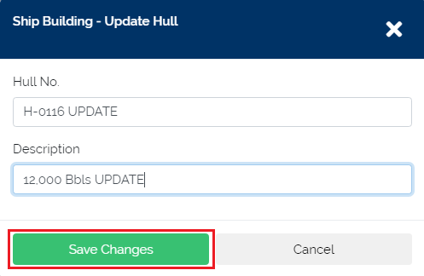

## Delete Hull

1. Click a specific hull record, in the “Ship Building/Ship Repair” table.

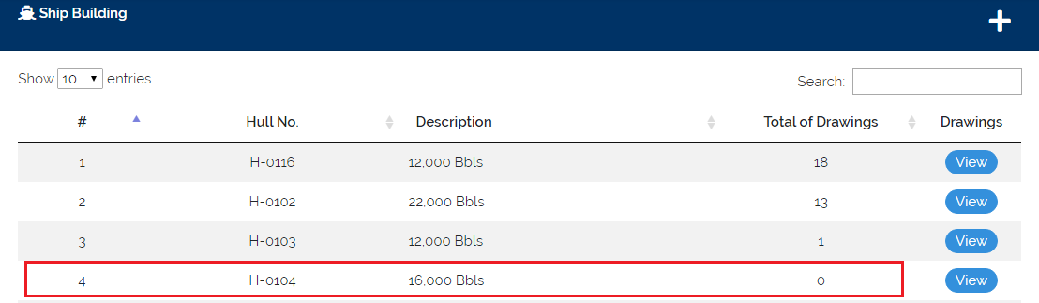

|  |
| --- |
| **Note:** Hull that used for preliminary drawings and hull with one or more drawing record are not enabled to delete. |

1. Hull details will be shown. Click the “Delete” button.

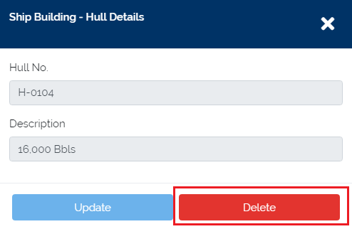

1. Delete Confirmation will be shown. Click “Yes” button to proceed.

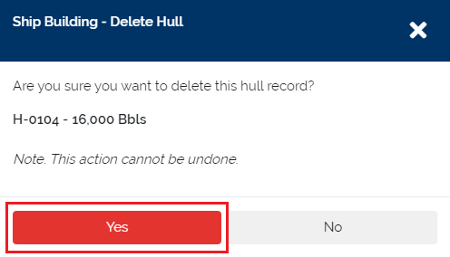

## View Special Project Drawing Records

1. On the side navigation bar, click “Drawings” and select “Special Projects” from the dropdown menu.

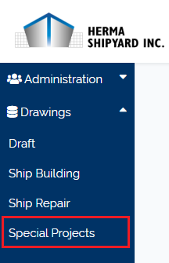

1. It will be linked on “Special Projects” page.

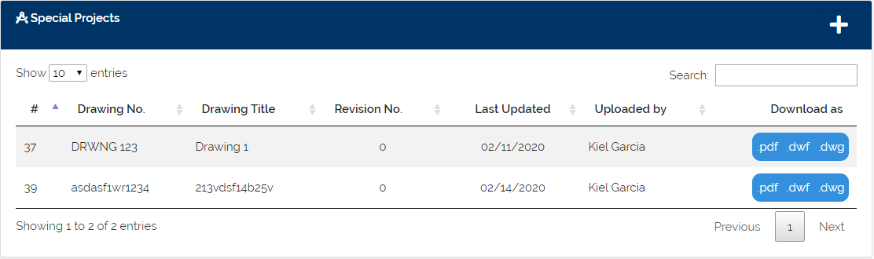

## View Ship Building and Ship Repair Drawing Records

1. In the “Ship Building/Ship Repair” hull records, click the “View” button of a specific hull record.

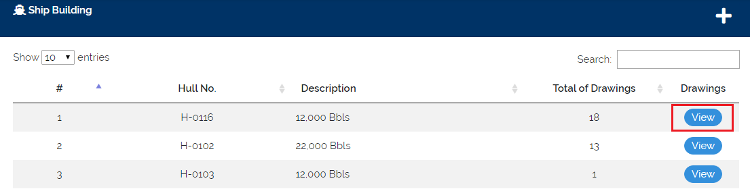

1. It will be linked on the drawing records of the specific hull.

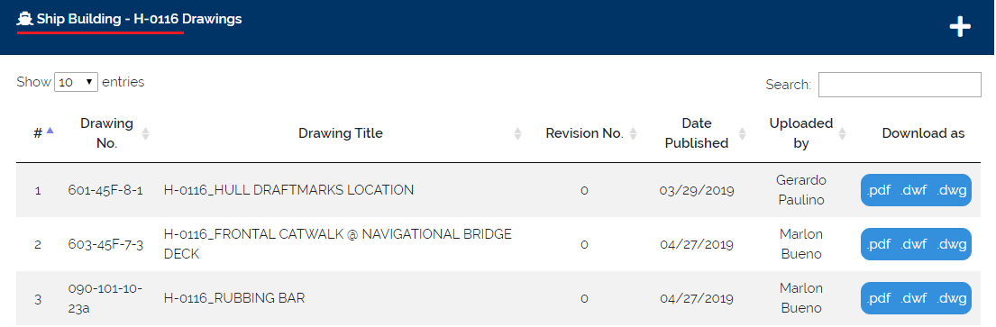

## Search Drawing

1. Click on the search text box and input a drawing details. System will automatically filter the records based on users input.

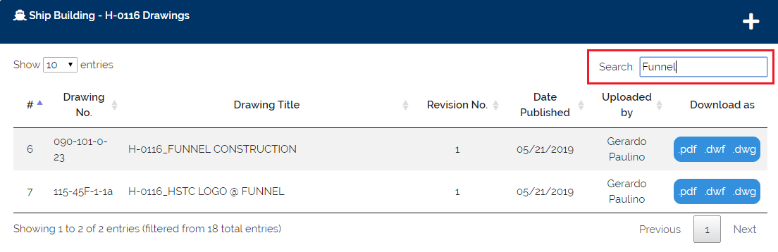

## Add New Drawing

1. Click “**+**” in the drawing table.

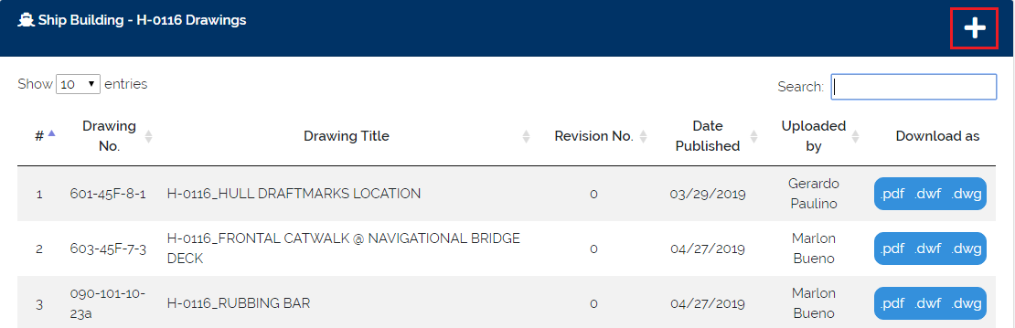

1. Fill up the required fields in the new drawing form. When fields are done, click “Save” button.

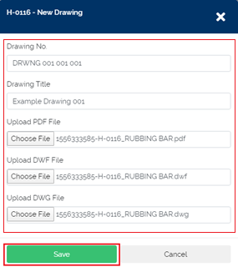

## Update Drawing Details

1. Click a specific drawing record.

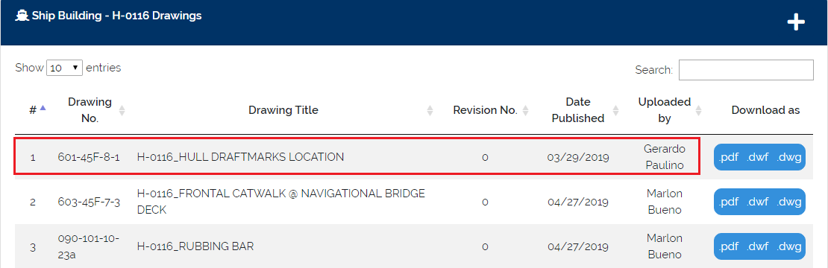

1. Drawing details will be shown. Click the “Update” button to disable text fields.

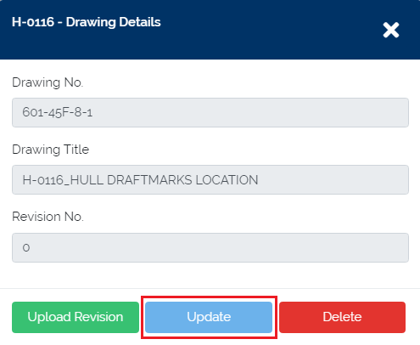

|  |
| --- |
| **Note:** Editing “Revision No.” text field is not available. This value will automatically change when you upload drawing revisions. |

1. When changes are done, click “Save Changes” button.

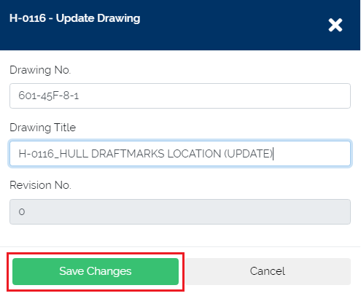

## Upload Drawing Revision

1. Click a specific drawing record.



1. Drawing details will be shown. Click the “Upload Revision” button.

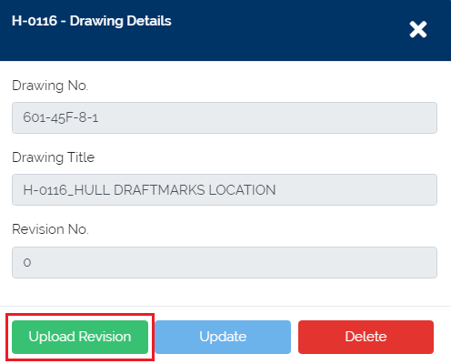

1. Attach PDF, DWF, and DWG drawing files. Then click “Upload” button to update drawing files.

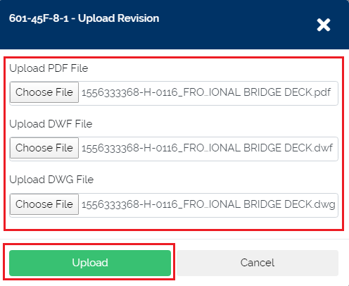

## View Drawing Revision History

1. Click a specific drawing record with 1 or more Revision no.

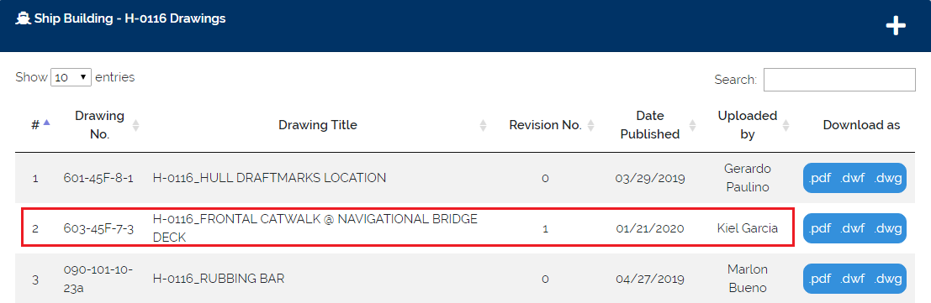

1. Drawing details will be shown. Click the “Revision History” to drop down revision details. Previous versions are available to download.

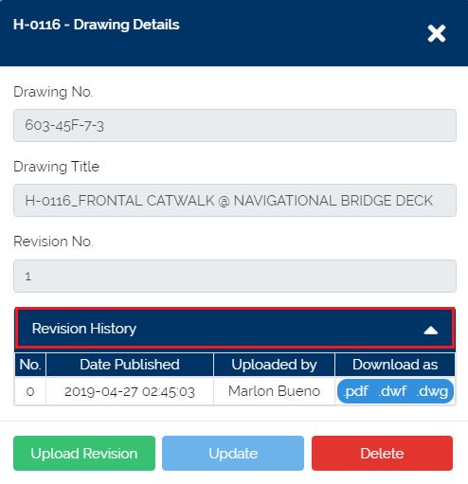

## Download Drawing

1. Click “PDF, DWF and DWG” download buttons of a specific drawing record.

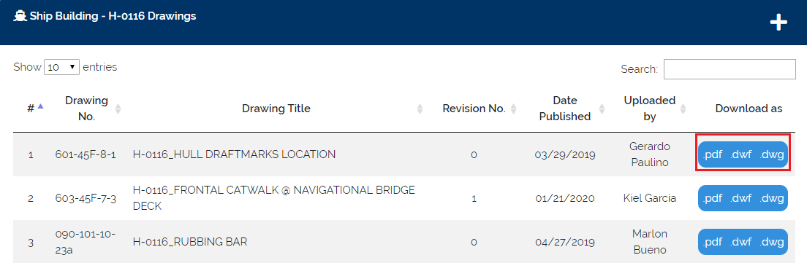

## Delete Drawing

1. Click a specific drawing record.

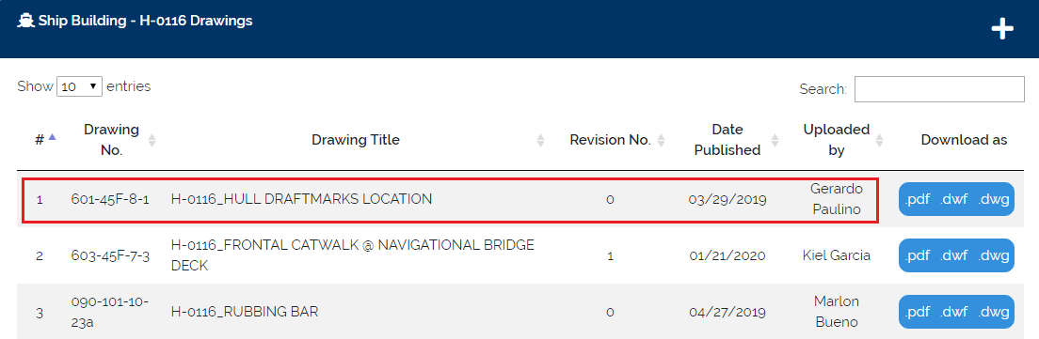

1. Drawing details will be shown. Click “Delete” button.

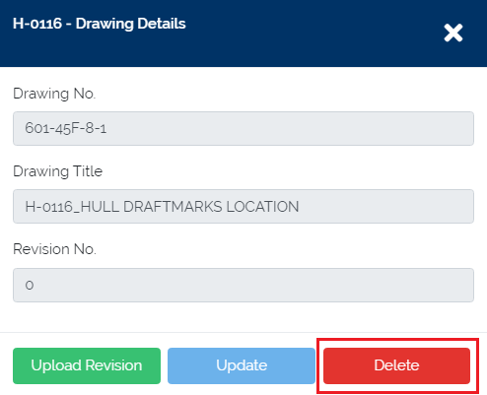

1. Delete confirmation will be shown. Click “Yes” to proceed.

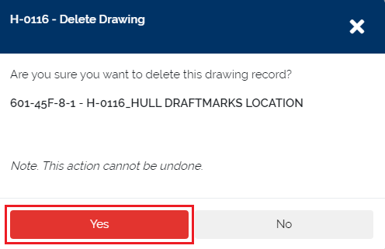

## View Draft Records

1. On the side navigation bar, click “Drawings” and select “Drafts” from the dropdown menu.

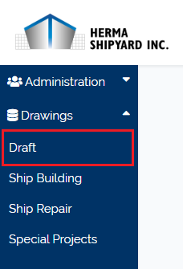

1. It will be linked on “Drafts” page.

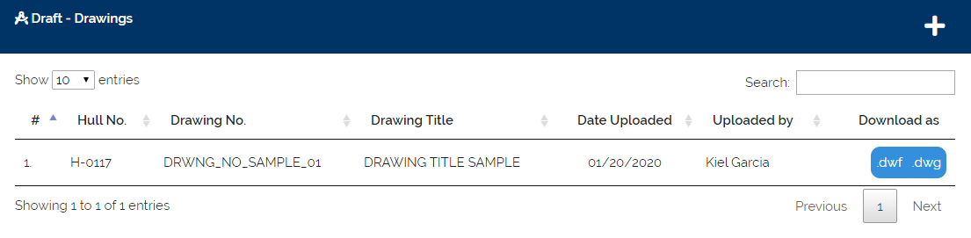

## Search Draft

1. Click on the search text box and input a Drawing details. System will automatically filter the records based on users input.

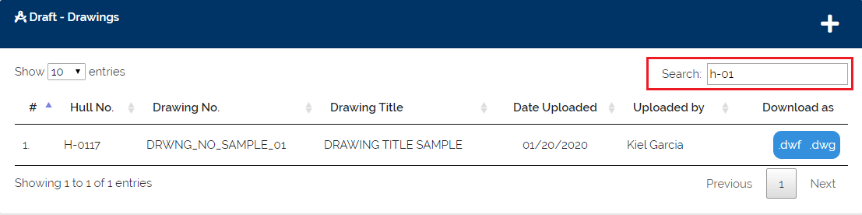

## Add New Draft

1. Click the “**+**” button in the Drafts table.

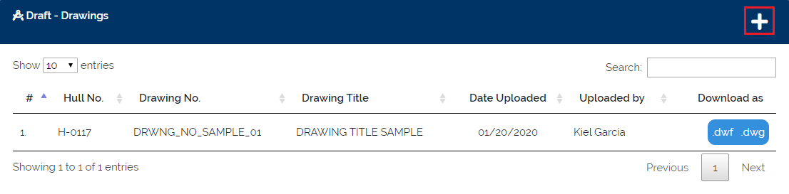

1. Fill up the required fields in the new draft form. Click “Save” button when all fields are filled.

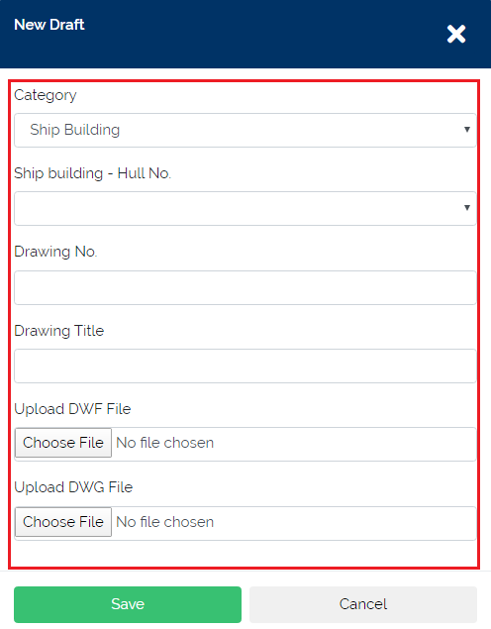

|  |
| --- |
| **Note:** If category is “Special Projects”, selection for Hull no. is not available. |

## Update Draft Details

1. Click a specific draft record.

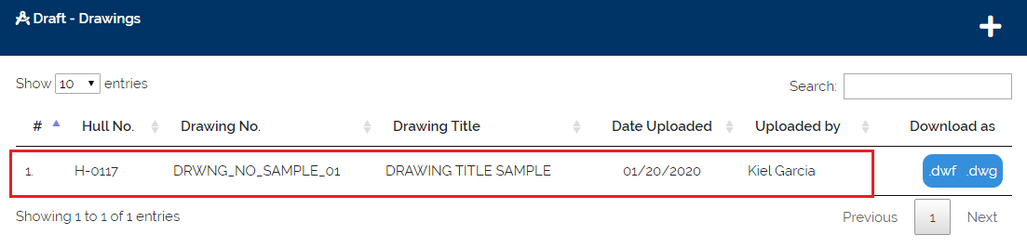

1. Draft details will be shown. Click “Update” button to disable text fields.

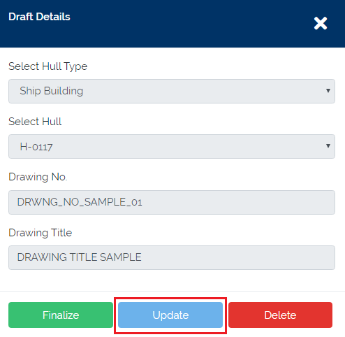

1. Click “Save Changes” button when changes are done.

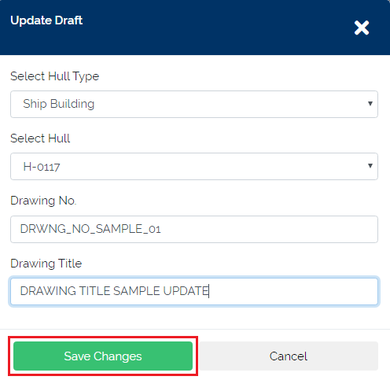

## Finalize Draft Record

1. Click a specific draft record.



1. Draft details will be shown. Click “Finalize” button.

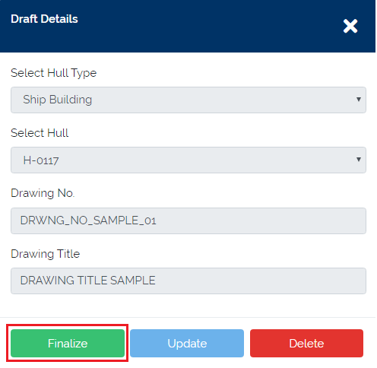

|  |
| --- |
| **Note:** Take note the hull type and hull no. This will be the path of the finalized draft. |

1. Upload the approved drawing files PDF, DWF, and DWG. Then click “Yes” to proceed.

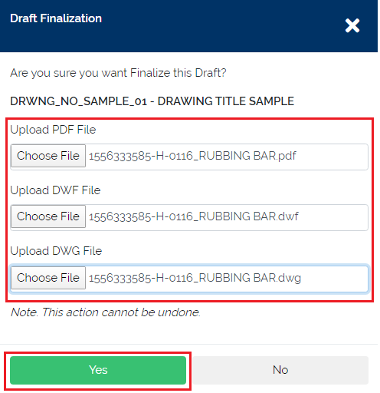

## Delete Draft

1. Click a specific draft record.



1. Draft details will be shown. Click “Delete” button.

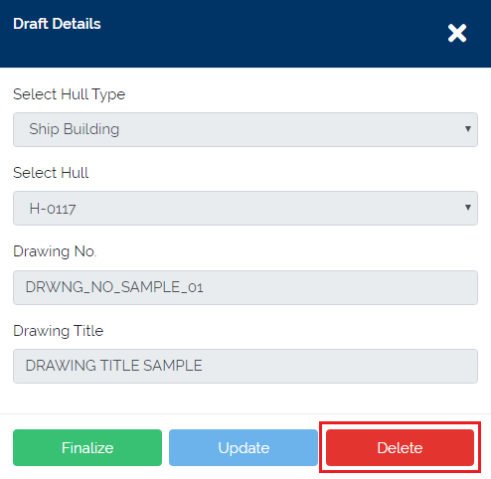

1. Delete confirmation will be shown. Then click “Yes” to proceed.

